**Step 1 – Rough Research**

Research information about the software for your assigned operating system (OS) environment.

· Guide your research according to the suggested topic list below

· Feel free to copy-and-paste as long as you keep track of your bibliographic references.

· Do not be too picky or concerned about formatting as you will organize this information later in step 2

· Select things that look interesting and don’t forget to include graphics images as well

· Upload your rough research notes to your repository when you are done.

Topic A – Productivity & Application Software

### **[Toggl](https://toggl.com/?utm_source=zapier.com&utm_medium=referral&utm_campaign=zapier&utm_source=zapier.com&utm_medium=referral&utm_campaign=zapier)**

*Best for tracking time while remote*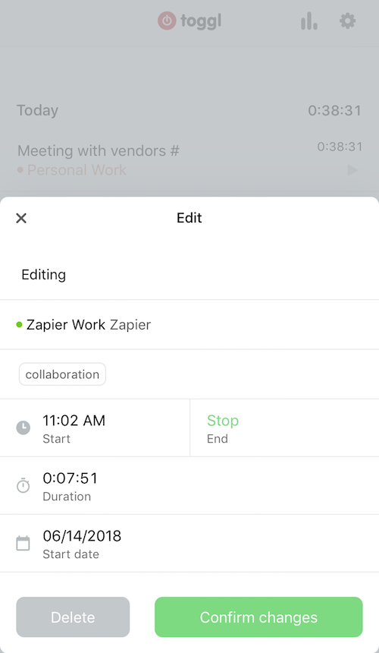

Toggl is among the [best time-tracking apps](https://zapier.com/blog/best-time-tracking-apps/), and it stands out on the iPhone for its ease of use. If you need to track time spent in meetings, at a client visit, or while doing anything when you're away from your desk, Toggl is the best app for the job on iPhone. Whether you need to keep tabs on billable hours or simply want to record time on task for your own productivity purposes, it's the app to download. Toggl also wins hearts for having a free tier of service that's actually quite useful, though you may need to pony up to a paid plan for additional reporting tools and project management features. Toggl works across a number of platforms (Android, Chrome, Linux, macOS, web, Windows), and time you record via the iPhone app will sync to your other devices.

### **[Shortcuts by Apple](https://itunes.apple.com/us/app/shortcuts/id915249334?utm_source=zapier.com&utm_medium=referral&utm_campaign=zapier)**Shortcuts app for iPhone

### ***Best for creating automations***

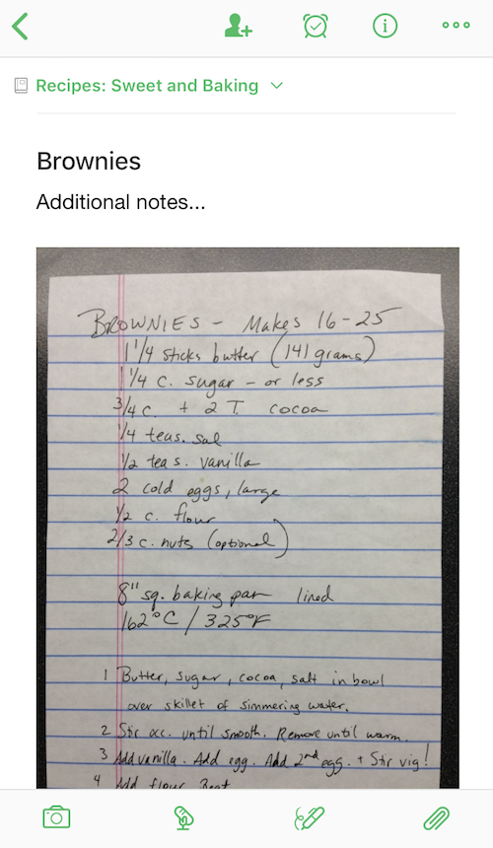**Apple's Shortcuts app lets you create and trigger automations, such as "upload the most recent photo I took to my cloud storage account," from your iPhone either with the touch of a button or by using Siri. The app is more or less an updated version of Apple's Workflow app for iOS 12 and later. With this app and a little tinkering, you have the power to create a multitude of automations in the vein of "when I press the button or ask Siri, do this action." You don't need any technical prowess, as you can choose templates from the app's Library, such as "when I press this button, get directions to the next event on my calendar." If you're reasonably comfortable with technology, however, you can add quite complex automations, many beyond the limits of Shortcuts and iOS if you use Zapier webhooks. See Zapier's tutorial on** [**how to create Shortcuts beyond iOS**](https://zapier.com/blog/zapier-siri-shortcuts/)**.**

**Price: free**

### **[Evernote](https://evernote.com/?utm_source=zapier.com&utm_medium=referral&utm_campaign=zapier&utm_source=zapier.com&utm_medium=referral&utm_campaign=zapier)**

***Best for taking notes of all kinds***

**No other note-taking app has as much functionality on the iPhone as Evernote. Evernote lets you quickly capture any type of note, whether it's a voice memo, checklist, text note, or an image. You can snap photos that contain text, such as a page of a book or a whiteboard from a meeting, and Evernote will not only save them so they're accessible to you any time, but also make the text searchable using optical character recognition (OCR). It works for both typed text and handwriting. It's an excellent app for productivity enthusiasts and essential on the iPhone. Evernote also has apps for all major platforms, including the web.**

**Price: free**

Topic B – Entertainment & Media Software

### **Spotify**

****Free (subscription required); iPad, iPhone and Android

### **Netflix**

****Free (subscription required); iPad, iPhone and Android

Box-set junkies love Netflix for its exhaustive back catalogue of on-demand titles, as well as a growing collection of original series (including the stellar House of Cards). The pin-sharp visuals and new AirPlay function for iOS 7 users – allowing devices to sync with any Apple TV – make the £5.99 subscription worth every penny.

## 

## 

## 

## 

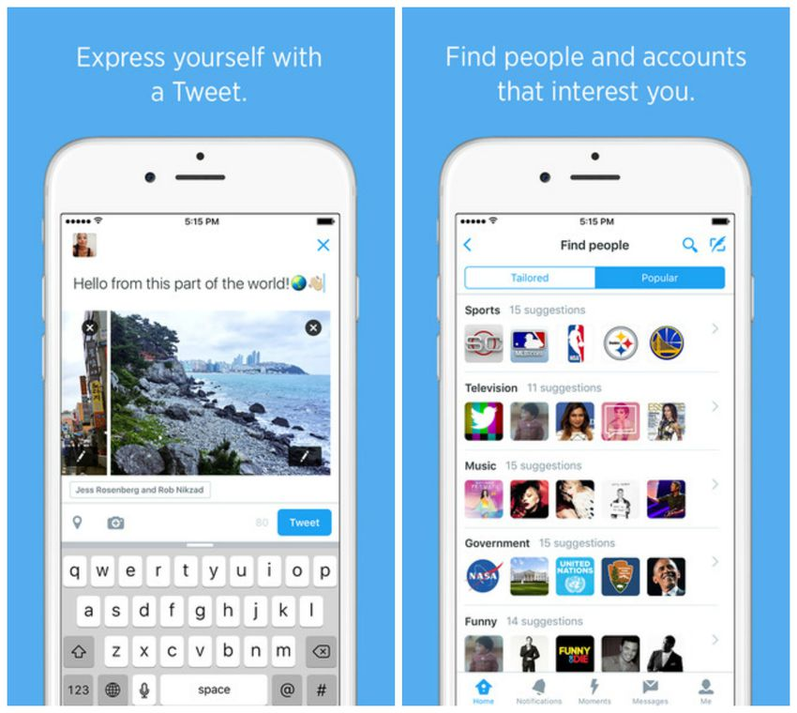

[**PREV**](https://mashable.com/2015/12/10/best-social-iphone-apps-of-all-times/) **1415 [NEXT](https://mashable.com/2015/12/10/best-social-iphone-apps-of-all-times/#)**

## **2. TwitterIt took a little too long for** [**Twitter**](https://itunes.apple.com/us/app/twitter/id333903271) **to deliver an iPhone app. In fact, Twitter never really did. Instead, the company bought popular app Tweetie and built upon its platform (though it's likely that whatever Tweetie code existed is long since gone). Today, the native Twitter client app’s utility and importance is undeniable. Having a dedicated app that Twitter could focus on and promote helped Twitter, for a time, experience almost meteoric growth. With its tabbed interface and sharp aqua design, it’s a rich app that highlights the best Twitter has to offer, while it makes it easy to discover the service's newest features (hey, look at those Moments!). Twitter is now struggling to grow its user base, but there's no question that little aqua bird and the iPhone have helped each other fly high.**

**IMAGE: TWITTER**

Topic C – Programming Tools & Environment

DOCUMENTATION

1. As any programmer would confirm, documentation is one of the main attributes at the initial stages of iOS application development.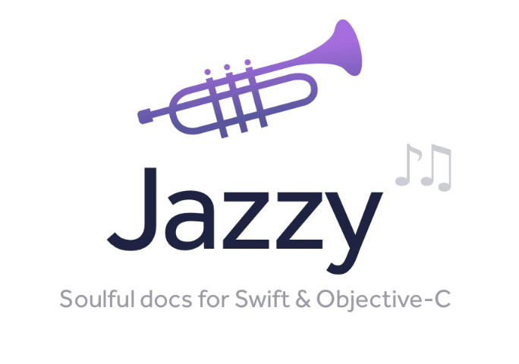

[Jazzy](https://github.com/realm/jazzy)This command-line utility can produce an Apple-style documentation for Swift and Objective-C. Jazzy uses SourceKit and the Clang AST representation of your code and its comments for generating more accurate results. In fact, this tool creates a standalone website with every part of your code and the documentation you’ve written in it. The clear and simple output it generates can be installed in the popular Dash documentation viewer.

## 

## 

## 

## DEBUGGING TOOLS

Identifying bugs is an important part of iOS mobile app development but what is even more important is finding out the real cause of each error. The following debugging tools are designed to help you with this task.



[Hyperion](https://github.com/willowtreeapps/Hyperion-iOS):Hyperion is a design debugging solution that can be integrated into any iOS app. This iOS app development tool sits discreetly under your application so that you can easily use it to inspect your program whenever you need it. Hyperion offers three default plugins: the View Inspector to check the properties of any view, the Measurements plugin to measure the distance between two views, and the Slow Animations plugin which allows reducing animation speed in-app.

BACKEND SERVICES

As it often happens, developers are aimed at providing their iOS apps with some extra functionality like the ability to share data with a server, send push notifications, and so on. The following iOS development tools will be a good choice for this purpose.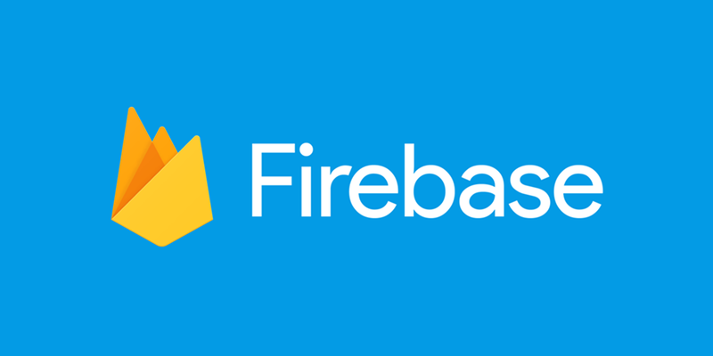

[Firebase](https://firebase.google.com/):Firebase is a BaaS  (Backend-as-a-Service) that can be your server, datastore, and API at the same time. With Firebase there’s no need to write any backend code. The solution will let you store and sync data over all your clients in real time. Any time data changes, Firebase updates apps on every device (mobile or web). In case your Firebase-powered app is working offline, its data will be synchronized once it regains connectivity.

## REVISION CONTROL

**If an iOS app is being created by a team of developers, a revision control is crucial to the project’s success.**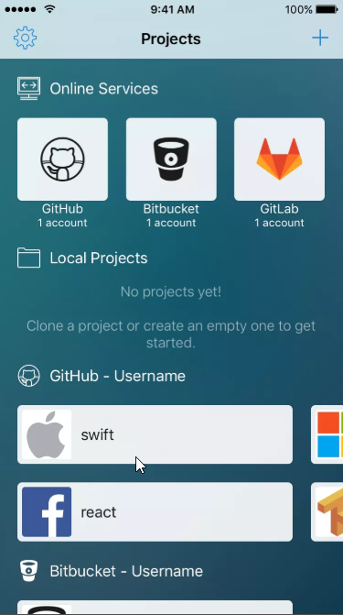

[**Source**](https://itunes.apple.com/app/source-git-client-and-code-editor/id1186180369)**:Source is a git client and code editor for iOS devices. It works as an efficient code editor that supports syntax highlighting for more than a hundred languages. Source is a git client so you can commit, pull, push, branch, etc. with specific integrations for GitHub, Bitbucket, and Gitlab.**

**The great thing about the tool is that it provides an integrated coding keyboard with common programming characters which can be used over iOS as a third party keyboard.**

Topic D – System Tools

[Tenorshare ReiBoot](https://www.any-data-recovery.com/product/free-iphone-ipad-ipod-reboot.html) is a free tool which can fix many iOS device "recovery mode" errors with a single click.This iPhone system repair tool comes with both Windows and Mac version.

It aims to help you in the following situations:

* iPhone stuck on Apple logo.
* iPhone frozen on Apple screen.
* iPhone stuck on recovery mode/red iTunes logo.
* iPhone stuck on reboot loop.
* iPhone won't start after jailbreaking.
* iPhone stuck on connect to iTunes status.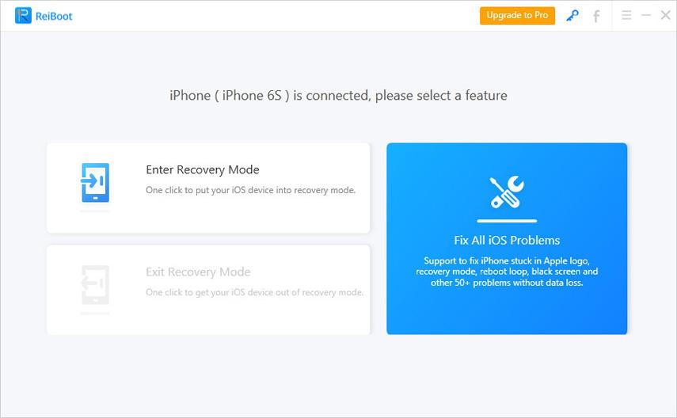

The software is super easy to use. No special skill is required. Essentially you just connect the iOS device to your computer, wait for it to be detected, and either click "Enter Recovery Mode" or "Exit Recovery Mode".

[Tenorshare iCareFone](https://www.any-data-recovery.com/product/iphone-ipad-ipod-issue-fixing-software.html) (previously iPhone Care Pro) is the upgrade version of Tenorshare ReiBoot. Besides Repair Operating System, it has 5 other functions: File Manager, Speedup&Clean, Backup & Restore, Fix iOS Stuck and Ads Remove. You can fully control your device and transfer your own files, clean-up your iPhone storage, fix and repair iOS or even backup and restore your data without having to go through iTunes first.

**Repair Operating System**: If you are to repair iOS 12 iPhone XS/XS Max/XR/X/8/8 Plus/7/7 Plus/6S/6/SE/5s operating system, use Repair Operating System would be enough. The most amazing feature is that it could download matching firmware for your device so as to repair iPhone operating system.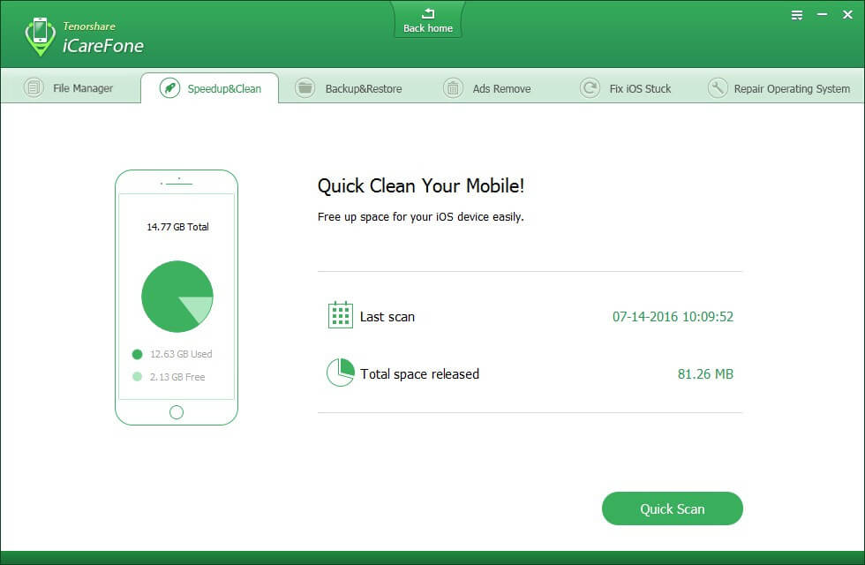

**Speedup & Clean**: Speedup & Clean is an important function that allows to tune up iOS. It thoroughly scans iPhone and removes cache files, temporary files, unwanted logs and cookies. These files accumulated as you use iPhone day by day, taking up valuable storage and dragging the whole device down. Upon my test, 60% storage is saved after Speedup & Clean. My iPhone 7 now travels lighter and faster.

Some iPhone system issues would cause iPhone data loss. That’s when [UltData](https://www.any-data-recovery.com/product/iphone-data-recovery.html) (initially iPhone Data Recovery) comes in handy. It’s a light and well-designed iPhone system repair app. The most important part is that it allows to restore lost data directly from iPhone. Even those without backups can retrieve their precious iPhone data with help from UltData.

A glance of main features are below:

* Recover data from iOS devices/iCloud backup/iTunes backup;
* Be able to recover messages, contacts, photos, videos, notes, call history, calendars,voicemail,voice memos, reminders, bookmarks, etc;
* Recover App data like WhatsApp, Instagram, Flickr, iPhoto, iMovie, etc;
* Compatible with the latest iOS 12/11;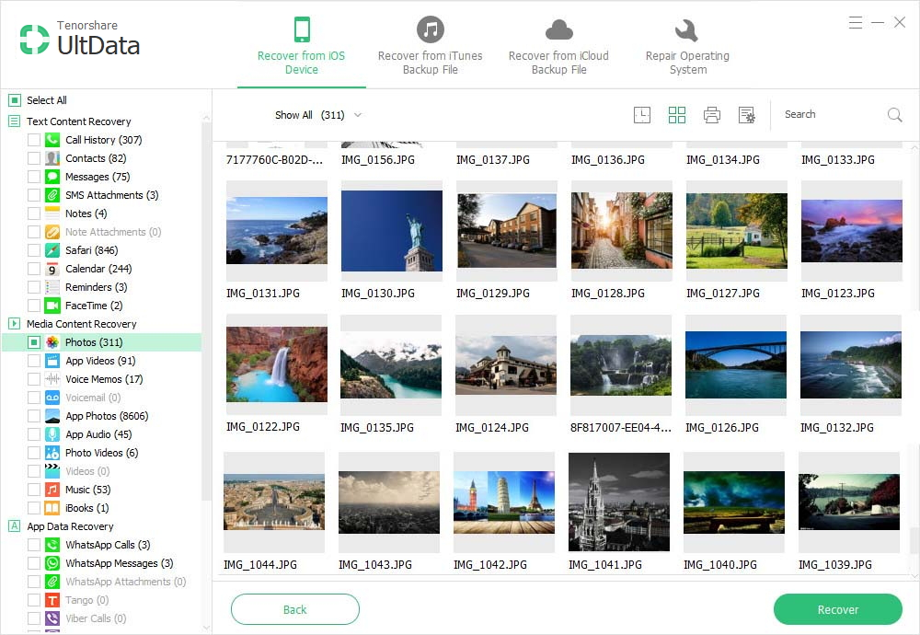
* Supports iPhone XS/XS Max/XR/X/8/8 Plus/7/7 Plus/6S/6/SE/5s/5 and lower. **Summary**: Once you’ve sorted out iPhone system repair all the three iPhone system repair tools, you’ll know when which one to use in different situations. Should you have any problems with iPhone operating system repair? Let us know by leaving a comment.

Topic E – Software Security & Update

Apple has one major update every year and one minor update every three months

There is security updates ever months

Topic F – File System & User Accounts

APFS

Topic G – Special Features of your OS

Performance

Up to 40% faster app launch

Apps launch faster in day-to-day use. And when you're pushing your iOS device to the limit, multitasking between lots of apps, they launch up to 2x faster

Up to 70% faster swipe to Camera.

Swiping to Camera from the Lockscreen happens faster so you never miss a moment.

Up to 50% faster keyboard display[1](https://www.apple.com/lae/ios/ios-12/features/#footnote-1)

The keyboard appears faster and typing is more responsive.

Facetime

Group FaceTime

Coming later this year, you’ll be able to FaceTime with up to 32 people at once.

FaceTime audio and video

Answer incoming Group FaceTime calls with video or audio on iPhone, iPad, and Mac, or join with audio on Apple Watch.

Join anytime

Join or add people to Group FaceTime at any time.

favorite iMessage apps.

Screen Time

Screen Time

New tools empower you to understand and make choices about how much time you spend using apps and websites.

Downtime

Set a specific time, like bedtime, when apps and notifications are blocked. You can choose which apps are on and off limits.

Always allowed

Create exceptions for apps you’d like your kids to have access to even during Downtime, such as Messages or education apps.

Topic H – Limitations of your OS

<https://zapier.com/blog/best-productivity-apps-for-iPhone/>

<https://www.telegraph.co.uk/technology/mobile-app-reviews/10510449/The-25-best-entertainment-apps-to-download-now.html>

<https://mashable.com/2015/12/10/best-social-iphone-apps-of-all-times/#38u2PO7ygiql>

<https://www.flexihub.com/best-ios-development-tools>

[www.any-data-recovery.com](http://www.any-data-recovery.com)

[https://www.apple.com › iOS › iOS 12](https://www.apple.com/lae/ios/ios-12/features/)